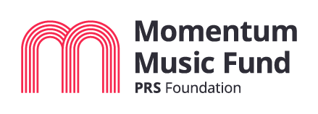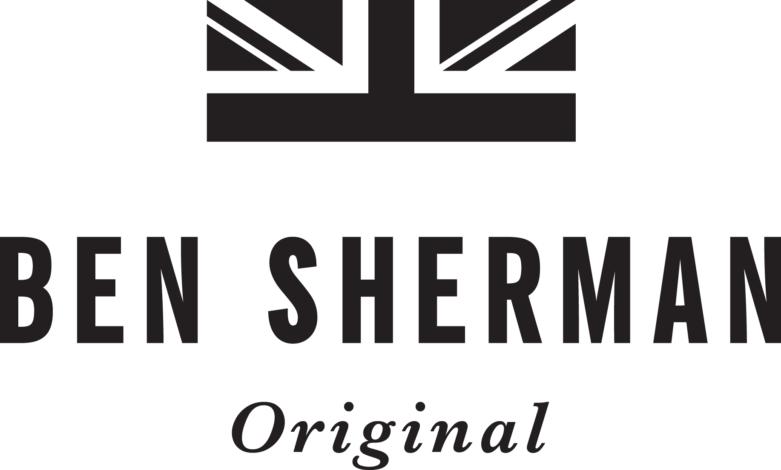

BEN SHERMAN TO PARTNER WITH
PRS FOUNDATION’S MOMENTUM MUSIC FUND

London, United Kingdom (April 30, 2019) Iconic British brand Ben Sherman is excited to announce its partnership with the PRS Foundation’s pioneering ‘Momentum Music Fund’ that will see the brand work with the UK’s leading charitable funder of new music and talent through a series of live events and in-store performances.

As part of the partnership, Ben Sherman will support Momentum funded artists beginning with a free live performance by West London duo Babeheaven, hosted at the brand’s flagship Carnaby Street store in London on Thursday 23rd May, 2019.

The series will continue in June, with Ben Sherman officially launching the first of their Ben Sherman Presents Momentum gigs at London’s music mecca The Old Blue Last on Great Eastern Street on Thursday 6th June, 2019 with performances by Hull band LIFE, Paris Youth Foundation and Zilo. To coincide with the series, Ben Sherman will also host a live performance from Momentum supported artist Ten Fé at their flagship as part of Carnaby Street Music Month.

On the partnership, Joe Frankland, Senior Grants and Programmes Manager at PRS Foundation comments, “Music and fashion have always been closely linked and play important roles in the melting pot that informs artistic inspiration. It makes sense for our pioneering Momentum Music Fund to join forces with one of the most iconic British brands and it is encouraging to see such a name investing in the future of music, at a time when support is so needed. We can’t wait to offer vital live and promotional platforms to more Momentum grantees.”

Talbot Logan, Senior Vice President Brand Management for Ben Sherman adds, “Ben Sherman has always had a long history with music and it’s subcultures, so partnering with the PRS Momentum Music Fund feels like a great partnership for the brand this year. The fund has a long history of supporting artists who have gone on to be nominated for and win such prestigious awards such as the BRIT Awards. We’re really excited to be a part of the fund for 2019 and look forward to supporting the newest talent from the British music scene.”

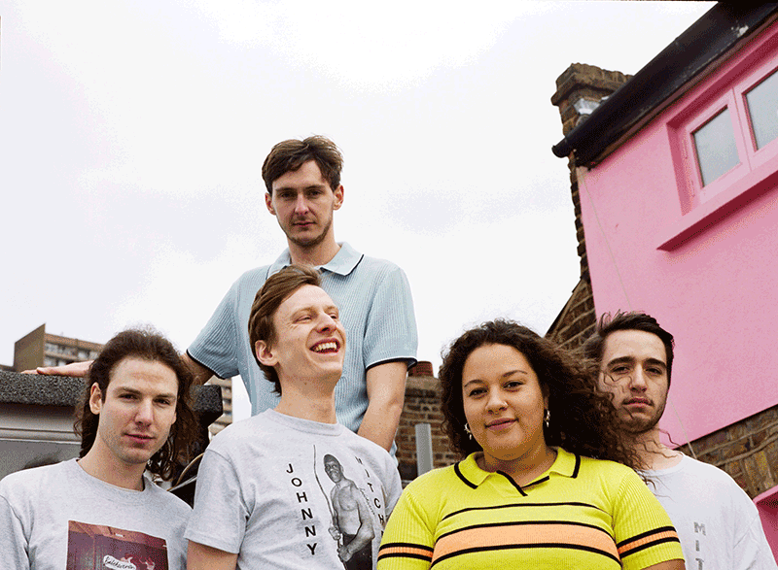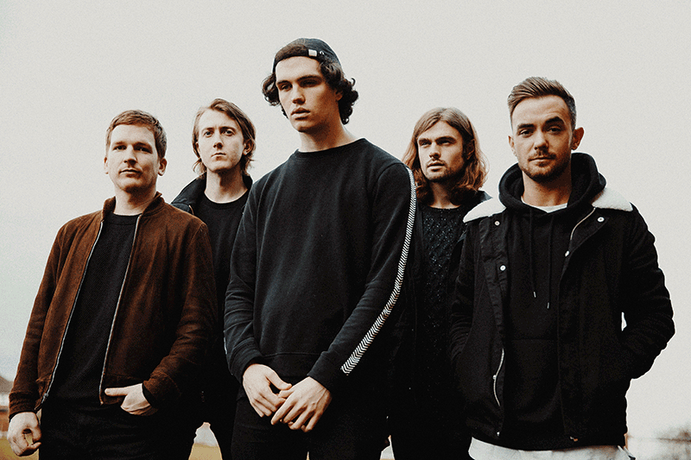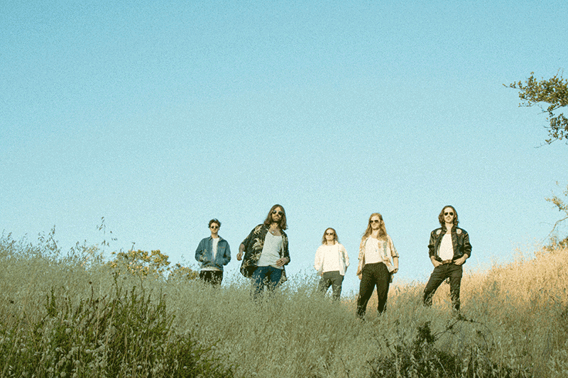

Managed by PRS Foundation, the Momentum Music Fund awards grants of between £5,000-£15,000 using funds from PRS Foundation, PPL, Creative Scotland, Arts Council of Wales, Welsh Government, Arts Council of Northern Ireland and Invest NI. Spotify, the official digital partner on the fund, contributes additional funding and a reward package containing exciting promotional opportunities and a close working relationship between Momentum artists and the Spotify team.

The Momentum Music 5 year impact report, which was launched at the Great Escape in May this year, showed that since 2013 the fund has supported over 200 artists, over 90 new albums and more than 100 UK tours totalling over 650 UK live dates. The 2016 impact report analysing the first three years of the fund revealed that Momentum has generated £13million for the UK music industry. PRS Foundation and Arts Council England initiated The Momentum Music Fund in 2013. Arts Council England originally established the need for this specific fund and supported the programme from 2013-18.

For a full rundown of all the artists supported so far see: http://prsfoundation.com/funding/momentum-music-fund/momentum-artists. The next deadline for applications to the Momentum Music Fund is 28th May 2019 via the PRS Foundation website. We are particularly interested in receiving more applications from outside of London: http://prsfoundation.com/funding/momentum-music-fund.

Listen to the latest Momentum supported artists on the Spotify Momentum playlist here.

For further information about Baird Group and Ben Sherman UK contact:
Charlotte Jackson, Marketing Manager, Baird Group
+ 0113 259 5500 | charlotte.jackson@baird-group.co.uk

For further information about Ben Sherman contact:
Lamayra Hanley-Evans, Account Director Village PR
+44 207 490 7394 | lamayra@wearevillage.com

For further information about PRS please contact:
Liam McMahon, Communications Manager, PRS Foundation
+44 (0) 7834 625 985 | liam@prsfoundation.com

For further information about the Momentum Music Fund please contact:
Winnie Sandy, Grants Coordinator, PRS Foundation
0203 741 4044 | winifred@prsfoundation.com

NOTES TO EDITORS
Babeheaven performance will take place on Thursday 23rd May, 2019 at Ben Sherman Carnaby Street,
50 Carnaby Street, Soho, London W1F 9QA.

The Ben Sherman Presents Momentum series will begin with performances and sets by Paris Youth, Zilo and Sports Team at The Old Blue Last, 38 Great Eastern Street, Hackney London EC2A 3ES on Thursday 6th June, 2019. Tickets for The Old Blue Last performances are available from the Ben Sherman site.

Ten Fé Carnaby Music Month performance will take place on Thursday 13th June 2019 at Ben Sherman Carnaby Street, 50 Carnaby Street, Soho, London W1F 9QA.

ABOUT BEN SHERMAN
Ben Sherman was a legend in his own right. Often described as ‘always embracing the new and the different’; he constantly searched for the very best. Born Arthur Benjamin Sugarman, he began his career making shirts for other designers. It wasn’t very long before his creative flair took over and he started designing his own shirts. By 1963 Ben Sherman was ready to launch his clothing line. For over fifty-six years the iconic Ben Sherman shirt and brand has been adopted by almost every seminal youth culture and style movement, it is still revered and worn by the style leaders of today. Now a global lifestyle brand Ben Sherman and the original Oxford shirt remains a modern icon, there is simply nothing quite like an original Ben Sherman shirt. www.bensherman.co.uk | @benshermanofficial

ABOUT PRS FOUNDATION
PRS Foundation is the UK’s leading charitable funder of new music and talent development. Since 2000 PRS Foundation has given more than £32 million to over 6,800 new music initiatives by awarding grants and leading partnership programmes that support music sector development. Widely respected as an adventurous and proactive funding body, PRS Foundation supports an exceptional range of new music activity - from composer residences and commissions to a network of talent development partners and showcases in the UK and overseas. www.prsfoundation.com | @PRSFoundation

SUPPORTING NOTES
About PPL
Founded in 1934, PPL is the UK music industry’s collective management organisation (CMO) for tens of thousands of performers and record companies. We license recorded music in the UK when it is played in public (shops, bars, nightclubs, offices etc.) or broadcast (BBC, commercial radio, commercial TV etc.) and ensure that revenue flows back to our members. These include both independent and major record companies, together with performers ranging from emerging grassroots artists through to established session musicians and influential festival headliners. PPL has a market-leading international collections business, with 87 agreements in place around the world, helping members to maximise their revenue when their repertoire is played overseas. We collected £218.8 million in the UK and internationally in 2017 and paid over 98,000 performers and record companies.

About Creative Scotland
Creative Scotland is the public body that supports the arts, screen and creative industries across all parts of Scotland on behalf of everyone who lives, works or visits here. We enable people and organisations to work in and experience the arts, screen and creative industries in Scotland by helping others to develop great ideas and bring them to life. We distribute funding provided by the Scottish Government and the National Lottery. For further information about Creative Scotland please visit www.creativescotland.com. Follow us @creativescots and www.facebook.com/CreativeScotland

About Arts Council of Wales
Arts Council of Wales is responsible for funding and developing the arts in Wales. We believe the arts are central to the life and wellbeing of the nation. We invest public funding, using these funds to create opportunities for people to enjoy and take part in the arts.
Our principal sponsor is the Welsh Government. We also distribute funding from the National Lottery and raise additional money where we can from a variety of public and private sector sources. Working together with the Welsh Government, we are able to show how the arts are helping to meet the Government’s policy ambitions.

About Welsh Government
The Welsh Government is the devolved Government for Wales.

About Arts Council of Northern Ireland
The Arts Council of Northern Ireland is the lead funding and development agency for the Arts. Our funding enables artists and arts organisations to increase access to the arts across society and deliver great art that is within everyone’s reach. National Lottery-funded arts programmes are bringing communities closer together, tackling prejudice, racism, isolation and mental health and improving emotional wellbeing. www.artscouncil-ni.org (twitter) @ArtsCouncilNI (facebook) \ArtsCouncilNI
The Arts Council of Northern Ireland Lottery Fund distributes a share of the money raised by The National Lottery for good causes.
- Over £30m is raised for good causes every week
- More than 500,000 projects have been funded
- Over £36bn has been raised since the Lottery started

About Invest NI
As the regional business development agency, Invest NI's role is to grow the local economy. We do this by helping new and existing businesses to compete internationally, and by attracting new investment to Northern Ireland. We are part of the Department for the Economy and provide strong government support for business by effectively delivering the Government’s economic development strategies.

About Spotify
Spotify transformed music listening forever when it launched in Sweden in 2008. Discover, manage and share over 40m songs for free, or upgrade to Spotify Premium to access exclusive features including offline mode, improved sound quality, Spotify Connect and ad-free listening.
Today, Spotify is the world’s most popular music streaming subscription service with a community of 207m users, including 96m subscribers, across 79 markets. We are the largest driver of revenue to the music business today.

About Culture Liverpool
Liverpool City Council is one of the largest local authorities in the UK serving a population of 491,500. It provides a wide range of services including education, social care, leisure, parks maintenance and is also takes a lead on the regeneration of the city. Through Culture Liverpool, the city council funds, produces and delivers culture and events in the city and manages international relations. The aim is to create year-round dynamic programmes which reflects the character and creativity of the city, placing citizens at its heart and inspiring all who participate and spectate. For more information visit www.liverpool.gov.uk/culture

